
DATA STRUCTURES AND ALGORITHMS
23CSE203
LAB MANUAL

Submitted By
NAME | P. Vishal Sri Chandra Varma
ROLL NO. | AV.SC.U4CSE25226
YEAR/SEM/SECTION | 2nd/3rd/CSE-C
Credits | 5

Submitted to | Dr. P. Gayathri
Designation | Asst. Professor (Sl. Grade)
Department | School of Computing

Index :
Sno | Experiments | Page no
1 | Recursion programs
2 | Linear and Binary searching
3 | Bubble , Selection , Insertion Sort
4 | Merge and Quick Sort
5 | Singly linked list (SLL)
6 | Doubly linked list (DLL)
7 | Stack operations
8 | Linear and circular queue
9 | BST tree operations
10 | AVL tree operations
11 | Heap tree
12 | Hashing (separate changing, Linear changing , quadratic probing )

Lab – 1 :
1) AIM: A rocket launch system displays a countdown before launch. Instead of using a loop, implement the countdown using recursion. Write a recursive Python program to display a countdown from n to 1, followed by "Launch!".
Program :
def countdown(n):
if n == 0:
print("Launch!")
return
print(n)
countdown(n - 1)
n = int(input("Enter countdown number: "))
countdown(n)
Output :
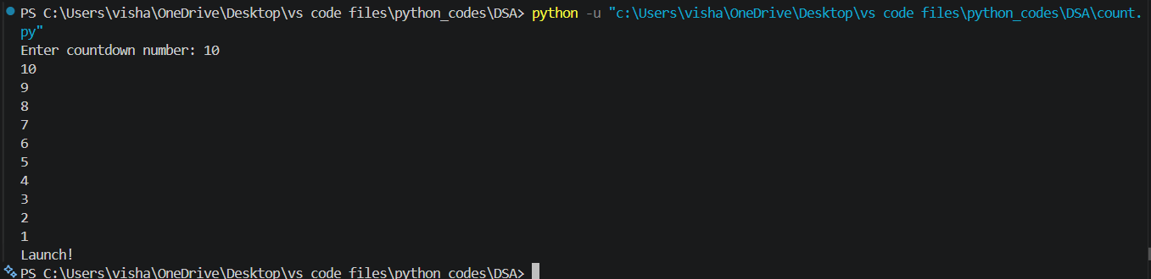
2) AIM: Banks calculate the growth of an investment using compound interest. The formula requires calculating powers, which can be implemented recursively. Write a recursive program to calculate Pⁿ (power), where:
P = principal growth factor, n = number of years
Program :
def power(P, n):
if n == 0:
return 1
return P * power(P, n - 1)
P = int(input("Enter base (P): "))
n = int(input("Enter exponent (n): "))
print("Result =", power(P, n))
output :
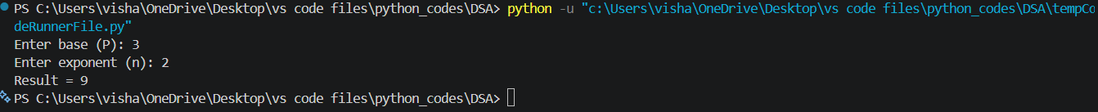
3) AIM: An HR department stores employee IDs in a list. Develop a recursive program to search for a given employee ID. Write a recursive function to search for an employee ID in a list.
Program :
def search_employee(emp_list, key, index):
if index == len(emp_list):
return False
if emp_list[index] == key:
return True
return search_employee(emp_list, key, index + 1)
employees = [101, 102, 103, 104, 105]
key = int(input("Enter Employee ID to search: "))
if search_employee(employees, key, 0):
print("Employee ID Found")
else:
print("Employee ID Not Found")
output :
4) AIM: In a logistics company, the number of possible ways to arrange n different parcels are calculated using the factorial formula (n!). Develop a recursive program to calculate the factorial of a given number.
Program :
def factorial(n):
if n == 0 or n == 1:
return 1
return n * factorial(n - 1)
num = int(input("Enter a number: "))
print("Factorial =", factorial(num))
output :
5) AIM: Write a recursive Python program to print the first “n” terms of the Fibonacci series.
Program :
def fibonacci(n):
if n == 0:
return 0
elif n == 1:
return 1
return fibonacci(n - 1) + fibonacci(n - 2)
terms = int(input("Enter number of terms: "))
print("Fibonacci Series:")
for i in range(terms):
print(fibonacci(i), end=" ")
output :
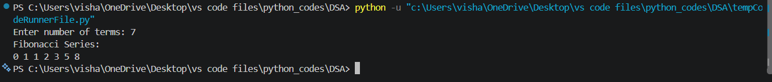

Lab -2 :
1) AIM: Linear search :
Program :
def linear_search(arr, key):
for i in range(len(arr)):
if arr[i] == key:
return i
return -1
arr = []
arr = list(map(int, input("Enter elements of the array separated by space: ").split()))
key = int(input("Enter the element to search for: "))
result = linear_search(arr, key)
if result != -1:
print(f"Element found at index: {result}")
else:
print("Element not found in the array.")
output :
2) AIM: Binary search :
Program :
def binary_search(arr, key):
low = 0
high = len(arr) - 1
while low <= high:
mid = (low + high) // 2
if arr[mid] == key:
return mid
elif arr[mid] < key:
low = mid + 1
else:
high = mid - 1
return -1
arr = list(map(int, input("Enter elements in ascending order: ").split()))
key = int(input("Enter the element to search: "))
result = binary_search(arr, key)
if result != -1:
print("Element found at index:", result)
else:
print("Element not found in the array.")
output :
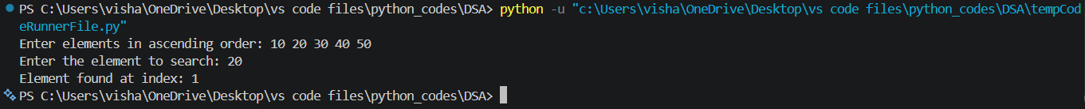

Lab-3:
- AIM: Bubble sort
Program :
def bubble_sort(arr):
n = len(arr)
for i in range(n):
for j in range(0, n - i - 1):
if arr[j] > arr[j + 1]:
arr[j], arr[j + 1] = arr[j + 1], arr[j]
return arr
arr = list(map(int, input("Enter numbers: ").split()))
print("Sorted List:", bubble_sort(arr))
Output :
- AIM: Selection sort
Program :
def selection_sort(arr):
n = len(arr)
for i in range(n):
min_index = i
for j in range(i + 1, n):
if arr[j] < arr[min_index]:
min_index = j
arr[i], arr[min_index] = arr[min_index], arr[i]
return arr
arr = list(map(int, input("Enter numbers: ").split()))
print("Sorted List:", selection_sort(arr))
Output :
- AIM: Insertion Sort
Program:
def insertion_sort(arr):
for i in range(1, len(arr)):
key = arr[i]
j = i - 1
while j >= 0 and arr[j] > key:
arr[j + 1] = arr[j]
j -= 1
arr[j + 1] = key
return arr
arr = list(map(int, input("Enter numbers: ").split()))
print("Sorted List:", insertion_sort(arr))
Output:

Lab-4:
1) Merge sort
Program :
def merge(arr, left, mid, right):
left_part = arr[left:mid + 1]
right_part = arr[mid + 1:right + 1]
i = 0
j = 0
k = left
while i < len(left_part) and j < len(right_part):
if left_part[i] <= right_part[j]:
arr[k] = left_part[i]
i += 1
else:
arr[k] = right_part[j]
j += 1
k += 1
while i < len(left_part):
arr[k] = left_part[i]
i += 1
k += 1
while j < len(right_part):
arr[k] = right_part[j]
j += 1
k += 1
def merge_sort(arr, left, right):
if left < right:
mid = (left + right) // 2
merge_sort(arr, left, mid)
merge_sort(arr, mid + 1, right)
merge(arr, left, mid, right)
arr = list(map(int, input("Enter numbers: ").split()))
merge_sort(arr, 0, len(arr) - 1)
print("Sorted List:", arr)
Output :

2)Quick Sort
Program :
def quick_sort(arr):
if len(arr) <= 1:
return arr
pivot = arr[len(arr) // 2]
left = [x for x in arr if x < pivot]
middle = [x for x in arr if x == pivot]
right = [x for x in arr if x > pivot]
return left + middle + right
arr = list(map(int, input("Enter numbers: ").split()))
print("Sorted List:", quick_sort(arr))
Output :

Lab-5:
1) AIM: Singly linked list (SLL)
Program :
class Node:
def __init__(self, data):
self.data = data
self.next = None

class LinkedList:
def __init__(self):
self.head = None

def create(self):
n = int(input("Enter the number of the nodes: "))
for i in range(n):
data = int(input("enter the data for node : "))
new_node = Node(data)
if self.head is None:
self.head = new_node
else:
current = self.head
while current.next:
current = current.next
current.next = new_node

def display(self):
current = self.head
while current:
print(current.data, end=" -> ")
current = current.next
print("None")

def count(self):
count = 0
current = self.head
while current:
count += 1
current = current.next
print(f"Total number of nodes: {count}")

def insert_at_beginning(self,data):
new_node = Node(data)
new_node.next = self.head
self.head = new_node

def insert_at_end(self,data):
new_node = Node(data)
if self.head is None:
self.head = new_node
return
else:
current = self.head
while current.next:
current = current.next
current.next = new_node

def insert_at_index(self, index, data):
if index < 0:
print("Index cannot be negative.")
return
new_node = Node(data)
if index == 0:
new_node.next = self.head
self.head = new_node
return
current = self.head
for i in range(index - 1):
if current is None:
print("Index out of bounds.")
return
current = current.next
if current is None:
print("Index out of bounds.")
return
new_node.next = current.next
current.next = new_node

def delete_at_beginning(self):
if self.head is None:
print("List is empty. Cannot delete.")
return
self.head = self.head.next

def delete_at_end(self):
if self.head is None:
print("List is empty. Cannot delete.")
return
if self.head.next is None:
self.head = None
return
current = self.head
while current.next.next:
current = current.next
current.next = None

def delete_at_index(self, index):
if index < 0:
print("Index cannot be negative.")
return
if self.head is None:
print("List is empty. Cannot delete.")
return
if index == 0:
self.head = self.head.next
return
current = self.head
for i in range(index - 1):
if current is None or current.next is None:
print("Index out of bounds.")
return
current = current.next
if current.next is None:
print("Index out of bounds.")
return
current.next = current.next.next

def delete(self, data):
if self.head is None:
return
if self.head.data == data:
self.head = self.head.next
return
current = self.head
while current.next is not None:
if current.next.data == data:
current.next = current.next.next
return
current = current.next

def searching(self, data):
current = self.head
index = 0
while current:
if current.data == data:
print(f"Data {data} found at index {index}.")
return
current = current.next
index += 1
print(f"Data {data} not found in the list.")

def sorting(self):
if self.head is None:
return
current = self.head
while current:
index = current.next
while index:
if current.data > index.data:
current.data, index.data = index.data, current.data
index = index.next
current = current.next

def main():
linked_list = LinkedList()
while True:
print("\nMenu:")
print("1. Create Linked List")
print("2. Display Linked List")
print("3. Insert at Beginning")
print("4. Insert at End")
print("5. Insert at Index")
print("6. Delete at Beginning")
print("7. Delete at End")
print("8. Delete at Index")
print("9. Search for an Element")
print("10. Count Nodes")
print("11. Delete a specific element")
print("12. Sort the linked list")
print("13. Exit")

choice = int(input("Enter your choice: "))

if choice == 1:
linked_list.create()
elif choice == 2:
linked_list.display()
elif choice == 3:
data = int(input("Enter data to insert at beginning: "))
linked_list.insert_at_beginning(data)
elif choice == 4:
data = int(input("Enter data to insert at end: "))
linked_list.insert_at_end(data)
elif choice == 5:
index = int(input("Enter index to insert at: "))
data = int(input("Enter data to insert: "))
linked_list.insert_at_index(index, data)
elif choice == 6:
linked_list.delete_at_beginning()
elif choice == 7:
linked_list.delete_at_end()
elif choice == 8:
index = int(input("Enter index to delete at: "))
linked_list.delete_at_index(index)
elif choice == 9:
data = int(input("Enter data to search for: "))
linked_list.searching(data)
elif choice == 10:
linked_list.count()
elif choice == 11:
data = int(input("Enter data to delete: "))
linked_list.delete(data)
elif choice == 12:
linked_list.sorting()
elif choice == 13:
print("Exiting...")
break
else:
print("Invalid choice. Please try again.")

main()
output :
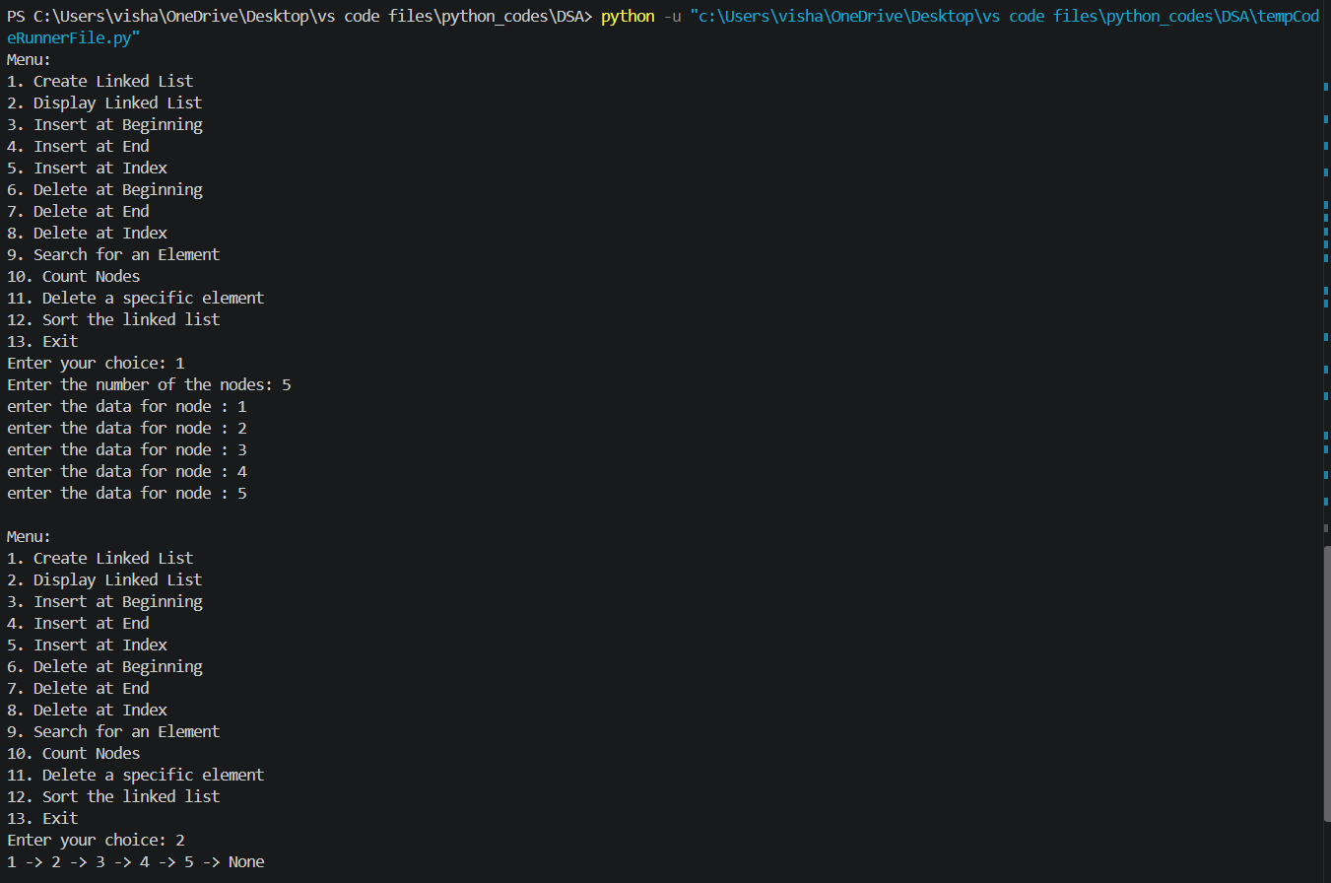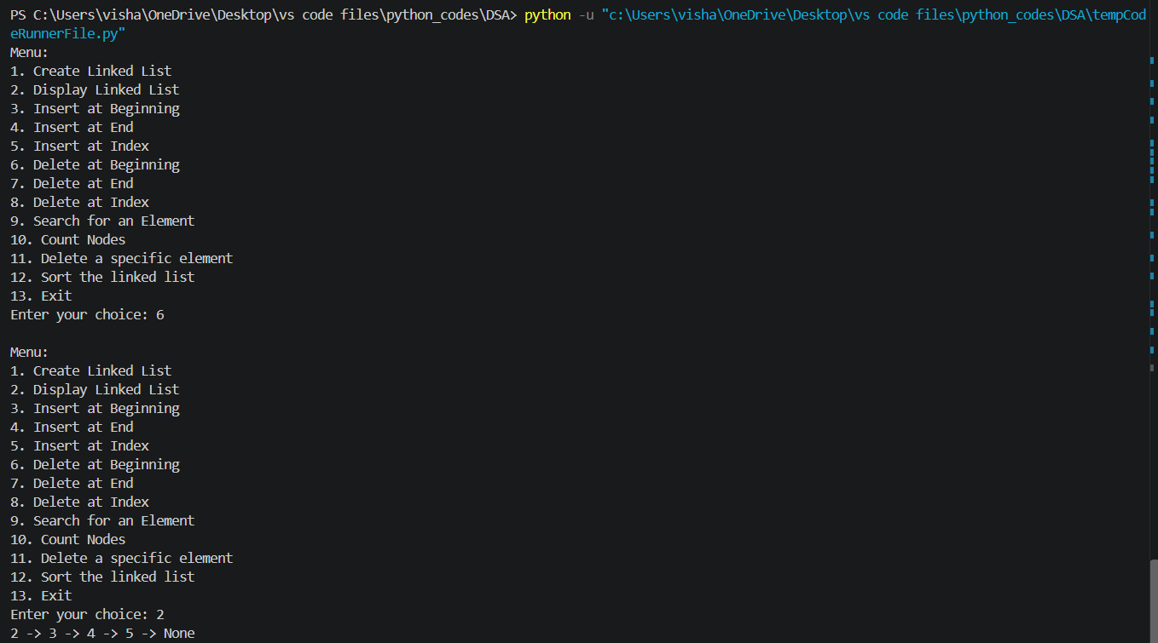

Lab-6:
1)AIM: Doubly linked list (DLL)
Program :
class Node:
def __init__(self, data):
self.data = data
self.prev = None
self.next = None

class DoublyLinkedList:
def __init__(self):
self.head = None
self.tail = None

def create(self):
n = int(input("Enter number of nodes: "))
for i in range(n):
data = int(input("Enter data: "))
new_node = Node(data)
if self.head is None:
self.head = self.tail = new_node
else:
new_node.prev = self.tail
self.tail.next = new_node
self.tail = new_node

def insert_at_beginning(self, data):
new_node = Node(data)
if self.head is None:
self.head = self.tail = new_node
else:
new_node.next = self.head
self.head.prev = new_node
self.head = new_node

def insert_at_end(self, data):
new_node = Node(data)
if self.tail is None:
self.head = self.tail = new_node
else:
new_node.prev = self.tail
self.tail.next = new_node
self.tail = new_node

def insert_at_index(self, index, data):
if index < 0:
print("Invalid index")
return
if index == 0:
self.insert_at_beginning(data)
return
temp = self.head
for i in range(index - 1):
if temp is None:
print("Invalid index")
return
temp = temp.next
if temp is None:
print("Invalid index")
return
if temp.next is None:
self.insert_at_end(data)
return
new_node = Node(data)
new_node.next = temp.next
new_node.prev = temp
temp.next.prev = new_node
temp.next = new_node

def delete_at_index(self, index):
if self.head is None or index < 0:
print("Invalid index")
return
temp = self.head
for i in range(index):
if temp is None:
print("Invalid index")
return
temp = temp.next
if temp is None:
print("Invalid index")
return
if temp.prev is None:
self.head = temp.next
else:
temp.prev.next = temp.next
if temp.next is None:
self.tail = temp.prev
else:
temp.next.prev = temp.prev

def delete_value(self, data):
temp = self.head
index = 0
while temp is not None and temp.data != data:
temp = temp.next
index += 1
if temp is None:
print("Value not found")
return
self.delete_at_index(index)

def count(self):
count = 0
temp = self.head
while temp is not None:
count += 1
temp = temp.next
print("Total number of nodes:", count)

def display_forward(self):
temp = self.head
while temp is not None:
print(temp.data, end=" <-> ")
temp = temp.next
print("None")

def display_backward(self):
temp = self.tail
while temp is not None:
print(temp.data, end=" <-> ")
temp = temp.prev
print("None")

def main():
dll = DoublyLinkedList()
while True:
print("\n1.Create 2.Insert beginning 3.Insert end 4.Insert index")
print("5.Delete value 6.Delete index 7.Count 8.Display forward")
print("9.Display backward 10.Exit")
choice = int(input("Enter choice: "))
if choice == 1:
dll.create()
elif choice == 2:
dll.insert_at_beginning(int(input("Enter data: ")))
elif choice == 3:
dll.insert_at_end(int(input("Enter data: ")))
elif choice == 4:
dll.insert_at_index(int(input("Enter index: ")), int(input("Enter data: ")))
elif choice == 5:
dll.delete_value(int(input("Enter value: ")))
elif choice == 6:
dll.delete_at_index(int(input("Enter index: ")))
elif choice == 7:
dll.count()
elif choice == 8:
dll.display_forward()
elif choice == 9:
dll.display_backward()
elif choice == 10:
break
else:
print("Invalid choice")

main()
output :
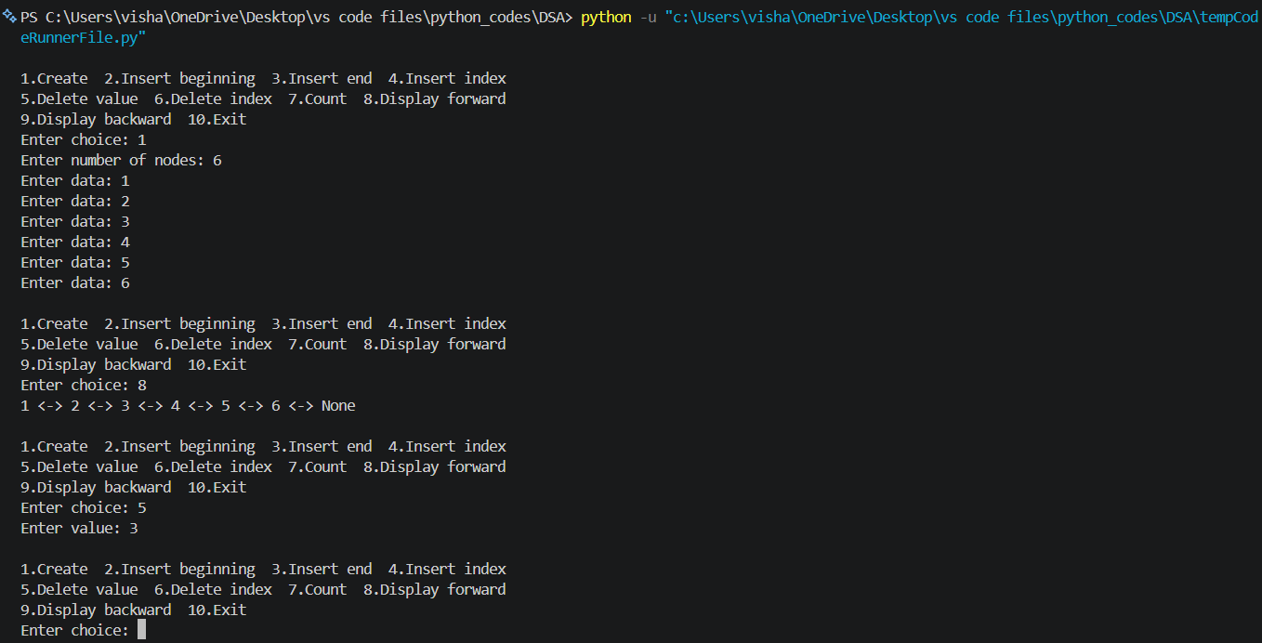

LAB-7:
1) AIM: Stack operations using arrays :
Program :
class Stack:
def __init__(self, size):
self.size = size
self.stack = [None] * size
self.top = -1

def push(self, item):
if self.top == self.size - 1:
print("Stack Overflow")
else:
self.top += 1
self.stack[self.top] = item
print(item, "pushed into stack")

def pop(self):
if self.top == -1:
print("Stack Underflow")
else:
item = self.stack[self.top]
self.stack[self.top] = None
self.top -= 1
print(item, "popped from stack")

def peek(self):
if self.top == -1:
print("Stack is empty")
else:
print("Top element:", self.stack[self.top])

def display(self):
if self.top == -1:
print("Stack is empty")
else:
for i in range(self.top, -1, -1):
print(self.stack[i])

size = int(input("Enter stack size: "))
s = Stack(size)
while True:
print("\n1.Push 2.Pop 3.Peek 4.Display 5.Exit")
choice = int(input("Enter choice: "))
if choice == 1:
s.push(int(input("Enter item: ")))
elif choice == 2:
s.pop()
elif choice == 3:
s.peek()
elif choice == 4:
s.display()
elif choice == 5:
break
else:
print("Invalid choice")
2) AIM: Stack operations using linked list :
Program :
class Node:
def __init__(self, data):
self.data = data
self.next = None

class Stack:
def __init__(self):
self.top = None

def push(self, data):
new_node = Node(data)
new_node.next = self.top
self.top = new_node
print(data, "pushed into stack")

def pop(self):
if self.top is None:
print("Stack Underflow")
else:
item = self.top.data
self.top = self.top.next
print(item, "popped from stack")

def peek(self):
if self.top is None:
print("Stack is empty")
else:
print("Top element:", self.top.data)

def display(self):
if self.top is None:
print("Stack is empty")
return
temp = self.top
while temp is not None:
print(temp.data)
temp = temp.next

s = Stack()
while True:
print("\n1.Push 2.Pop 3.Peek 4.Display 5.Exit")
choice = int(input("Enter choice: "))
if choice == 1:
s.push(int(input("Enter item: ")))
elif choice == 2:
s.pop()
elif choice == 3:
s.peek()
elif choice == 4:
s.display()
elif choice == 5:
break
else:
print("Invalid choice")

output :
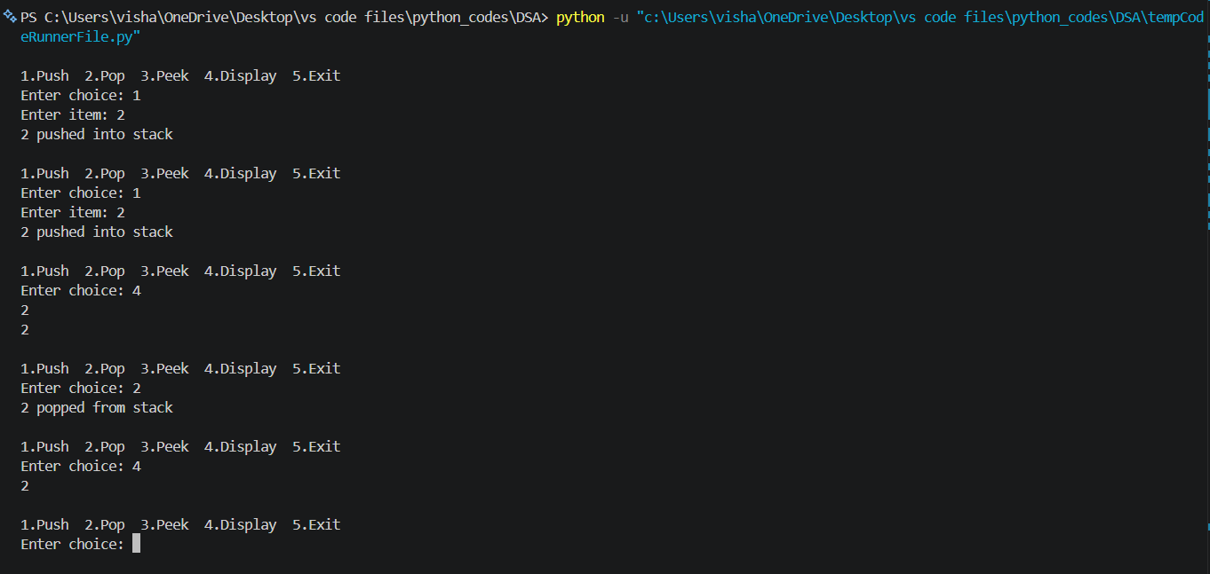

LAB-8:
1)AIM : Implement enqueue, dequeue, peek, and display using an array.
class Queue:
def __init__(self, size):
self.size = size
self.queue = [None] * size
self.front = -1
self.rear = -1

def enqueue(self, data):
if self.rear == self.size - 1:
print("Queue Overflow")
else:
if self.front == -1:
self.front = 0
self.rear += 1
self.queue[self.rear] = data
print(data, "inserted into queue")

def dequeue(self):
if self.front == -1:
print("Queue Underflow")
else:
data = self.queue[self.front]
self.queue[self.front] = None
if self.front == self.rear:
self.front = self.rear = -1
else:
self.front += 1
print(data, "deleted from queue")

def peek(self):
if self.front == -1:
print("Queue is empty")
else:
print("Front element:", self.queue[self.front])

def display(self):
if self.front == -1:
print("Queue is empty")
else:
print(self.queue[self.front:self.rear + 1])

size = int(input("Enter queue size: "))
q = Queue(size)
while True:
print("\n1.Enqueue 2.Dequeue 3.Peek 4.Display 5.Exit")
choice = int(input("Enter choice: "))
if choice == 1:
q.enqueue(int(input("Enter item: ")))
elif choice == 2:
q.dequeue()
elif choice == 3:
q.peek()
elif choice == 4:
q.display()
elif choice == 5:
break
else:
print("Invalid choice")
2) Implement enqueue, dequeue, peek, and display using an linked list.
Program :
class Node:
def __init__(self, data):
self.data = data
self.next = None

class Queue:
def __init__(self):
self.front = None
self.rear = None

def enqueue(self, data):
new_node = Node(data)
if self.rear is None:
self.front = self.rear = new_node
else:
self.rear.next = new_node
self.rear = new_node
print(data, "inserted into queue")

def dequeue(self):
if self.front is None:
print("Queue Underflow")
else:
data = self.front.data
self.front = self.front.next
if self.front is None:
self.rear = None
print(data, "deleted from queue")

def peek(self):
if self.front is None:
print("Queue is empty")
else:
print("Front element:", self.front.data)

def display(self):
if self.front is None:
print("Queue is empty")
return
temp = self.front
while temp is not None:
print(temp.data, end=" -> ")
temp = temp.next
print("None")

q = Queue()
while True:
print("\n1.Enqueue 2.Dequeue 3.Peek 4.Display 5.Exit")
choice = int(input("Enter choice: "))
if choice == 1:
q.enqueue(int(input("Enter item: ")))
elif choice == 2:
q.dequeue()
elif choice == 3:
q.peek()
elif choice == 4:
q.display()
elif choice == 5:
break
else:
print("Invalid choice")
Output :
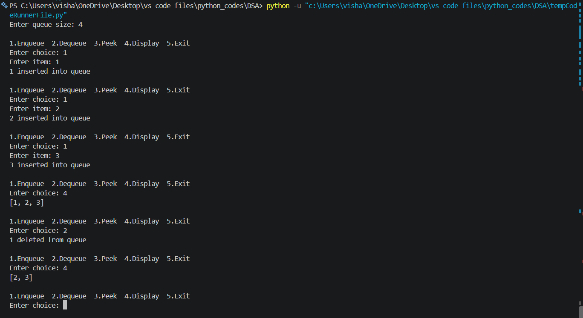
3) Implement circular queue enqueue, dequeue, and display using an array.
Program :
class CircularQueue:
def __init__(self, size):
self.size = size
self.queue = [None] * size
self.front = -1
self.rear = -1

def enqueue(self, item):
if (self.rear + 1) % self.size == self.front:
print("Queue Overflow")
elif self.front == -1:
self.front = 0
self.rear = 0
self.queue[self.rear] = item
print(item, "inserted into the queue")
else:
self.rear = (self.rear + 1) % self.size
self.queue[self.rear] = item
print(item, "inserted into the queue")

def dequeue(self):
if self.front == -1:
print("Queue Underflow")
# Only one element is present
elif self.front == self.rear:
item = self.queue[self.front]
self.queue[self.front] = None
self.front = -1
self.rear = -1
print(item, "deleted from the queue")
# More than one element
else:
item = self.queue[self.front]
self.queue[self.front] = None
self.front = (self.front + 1) % self.size
print(item, "deleted from the queue")

# Display operation
def display(self):
if self.front == -1:
print("Queue is empty")
else:
print("The elements of the queue are:")
i = self.front
while True:
print(self.queue[i])
if i == self.rear:
break
i = (i + 1) % self.size

# Create Circular Queue
size = int(input("Enter the size of the queue: "))
q = CircularQueue(size)
while True:
print("\n----- CIRCULAR QUEUE MENU -----")
print("1. Enqueue")
print("2. Dequeue")
print("3. Display")
print("4. Exit")
choice = int(input("Enter your choice: "))
if choice == 1:
item = int(input("Enter the element to enqueue: "))
q.enqueue(item)
elif choice == 2:
q.dequeue()
elif choice == 3:
q.display()
elif choice == 4:
print("Program terminated.")
break
else:
print("Invalid choice")

4) Implement circular queue enqueue, dequeue, peek, and display using a circular linked list.
Program :
class Node:
def __init__(self, data):
self.data = data
self.next = None

class CircularQueue:
def __init__(self):
self.front = None
self.rear = None

def enqueue(self, data):
new_node = Node(data)
if self.front is None:
self.front = self.rear = new_node
new_node.next = new_node
else:
new_node.next = self.front
self.rear.next = new_node
self.rear = new_node
print(data, "inserted into the queue")

def dequeue(self):
if self.front is None:
print("Queue Underflow")
elif self.front == self.rear:
data = self.front.data
self.front = self.rear = None
print(data, "deleted from the queue")
else:
data = self.front.data
self.front = self.front.next
self.rear.next = self.front
print(data, "deleted from the queue")

def peek(self):
if self.front is None:
print("Queue is empty")
else:
print("Front element:", self.front.data)

def display(self):
if self.front is None:
print("Queue is empty")
return
temp = self.front
while True:
print(temp.data, end=" -> ")
temp = temp.next
if temp == self.front:
break
print("(front)")

q = CircularQueue()
while True:
print("\n1.Enqueue 2.Dequeue 3.Peek 4.Display 5.Exit")
choice = int(input("Enter choice: "))
if choice == 1:
q.enqueue(int(input("Enter item: ")))
elif choice == 2:
q.dequeue()
elif choice == 3:
q.peek()
elif choice == 4:
q.display()
elif choice == 5:
break
else:
print("Invalid choice")

output:
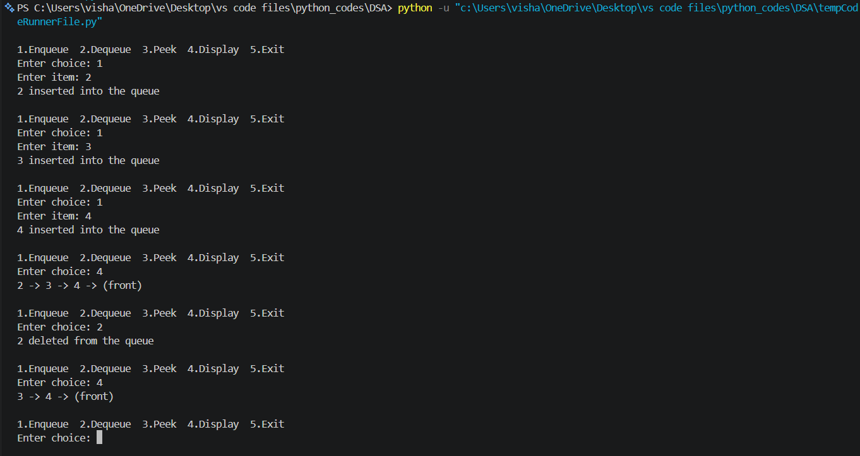

LAB-9:
1)AIM: BST tree operations
class Node:
def __init__(self, data):
self.data = data
self.left = None
self.right = None

def insert(root, x):
if root is None:
return Node(x)
if x < root.data:
root.left = insert(root.left, x)
elif x > root.data:
root.right = insert(root.right, x)
else:
print("Duplicate value is not allowed.")
return root

def inorder(root):
if root is None:
return
inorder(root.left)
print(root.data, end=" ")
inorder(root.right)

def preorder(root):
if root is None:
return
print(root.data, end=" ")
preorder(root.left)
preorder(root.right)

def postorder(root):
if root is None:
return
postorder(root.left)
postorder(root.right)
print(root.data, end=" ")

def find_min(root):
if root is None:
return None
while root.left is not None:
root = root.left
return root

def find_max(root):
if root is None:
return None
while root.right is not None:
root = root.right
return root

def search(root, data):
if root is None:
return None
if data < root.data:
return search(root.left, data)
elif data > root.data:
return search(root.right, data)
else:
return root

def count_nodes(root):
if root is None:
return 0
return count_nodes(root.left) + count_nodes(root.right) + 1

def count_leaves(root):
if root is None:
return 0
if root.left is None and root.right is None:
return 1
return count_leaves(root.left) + count_leaves(root.right)

def count_internal(root):
if root is None:
return 0
if root.left is None and root.right is None:
return 0
return count_internal(root.left) + count_internal(root.right) + 1

def height(root):
if root is None:
return -1
left_height = height(root.left)
right_height = height(root.right)
return max(left_height, right_height) + 1

def delete(root, x):
if root is None:
print("Element not found.")
return None
if x < root.data:
root.left = delete(root.left, x)
elif x > root.data:
root.right = delete(root.right, x)
else:
# Case 1: Node has no children
if root.left is None and root.right is None:
root = None
# Case 2: Node has only right child
elif root.left is None:
root = root.right
# Case 3: Node has only left child
elif root.right is None:
root = root.left
# Case 4: Node has two children
else:
successor = find_min(root.right)
root.data = successor.data
root.right = delete(root.right, successor.data)
return root

def print_level(root, level):
if root is None:
return
if level == 0:
print(root.data, end=" ")
else:
print_level(root.left, level - 1)
print_level(root.right, level - 1)

def level_order(root):
h = height(root)
for level in range(h):
print_level(root, level)

# =====================================================
# MAIN PROGRAM
# =====================================================

root = None
while True:
print("\n\n******** BINARY SEARCH TREE ********")
print("1. INSERT")
print("2. PREORDER TRAVERSAL")
print("3. INORDER TRAVERSAL")
print("4. POSTORDER TRAVERSAL")
print("5. FIND MINIMUM")
print("6. FIND MAXIMUM")
print("7. SEARCH")
print("8. DELETE")
print("9. COUNT NODES")
print("10. COUNT LEAVES")
print("11. COUNT INTERNAL NODES")
print("12. HEIGHT")
print("13. LEVEL ORDER TRAVERSAL")
print("14. EXIT")

choice = int(input("Enter your choice: "))
if choice == 1:
data = int(input("Enter the data to be inserted: "))
root = insert(root, data)
print("Element inserted successfully.")
elif choice == 2:
print("Preorder Traversal:", end=" ")
if root is None:
print("Tree is empty.")
else:
preorder(root)
print()
elif choice == 3:
print("Inorder Traversal:", end=" ")
if root is None:
print("Tree is empty.")
else:
inorder(root)
print()
elif choice == 4:
print("Postorder Traversal:", end=" ")
if root is None:
print("Tree is empty.")
else:
postorder(root)
print()
elif choice == 5:
node = find_min(root)
if node is None:
print("Tree is empty.")
else:
print("Minimum element:", node.data)
elif choice == 6:
node = find_max(root)
if node is None:
print("Tree is empty.")
else:
print("Maximum element:", node.data)
elif choice == 7:
data = int(input("Enter the data to be searched: "))
node = search(root, data)
if node is None:
print("Element", data, "is not found.")
else:
print("Element", data, "is found.")
elif choice == 8:
data = int(input("Enter the data to be deleted: "))
root = delete(root, data)
elif choice == 9:
print("Number of nodes:", count_nodes(root))
elif choice == 10:
print("Number of leaf nodes:", count_leaves(root))
elif choice == 11:
print("Number of internal nodes:", count_internal(root))
elif choice == 12:
print("Height of BST:", height(root))
elif choice == 13:
print("Level Order Traversal:", end=" ")
if root is None:
print("Tree is empty.")
else:
level_order(root)
print()
elif choice == 14:
print("Program terminated.")
break
else:
print("Invalid choice. Please try again.")
output :
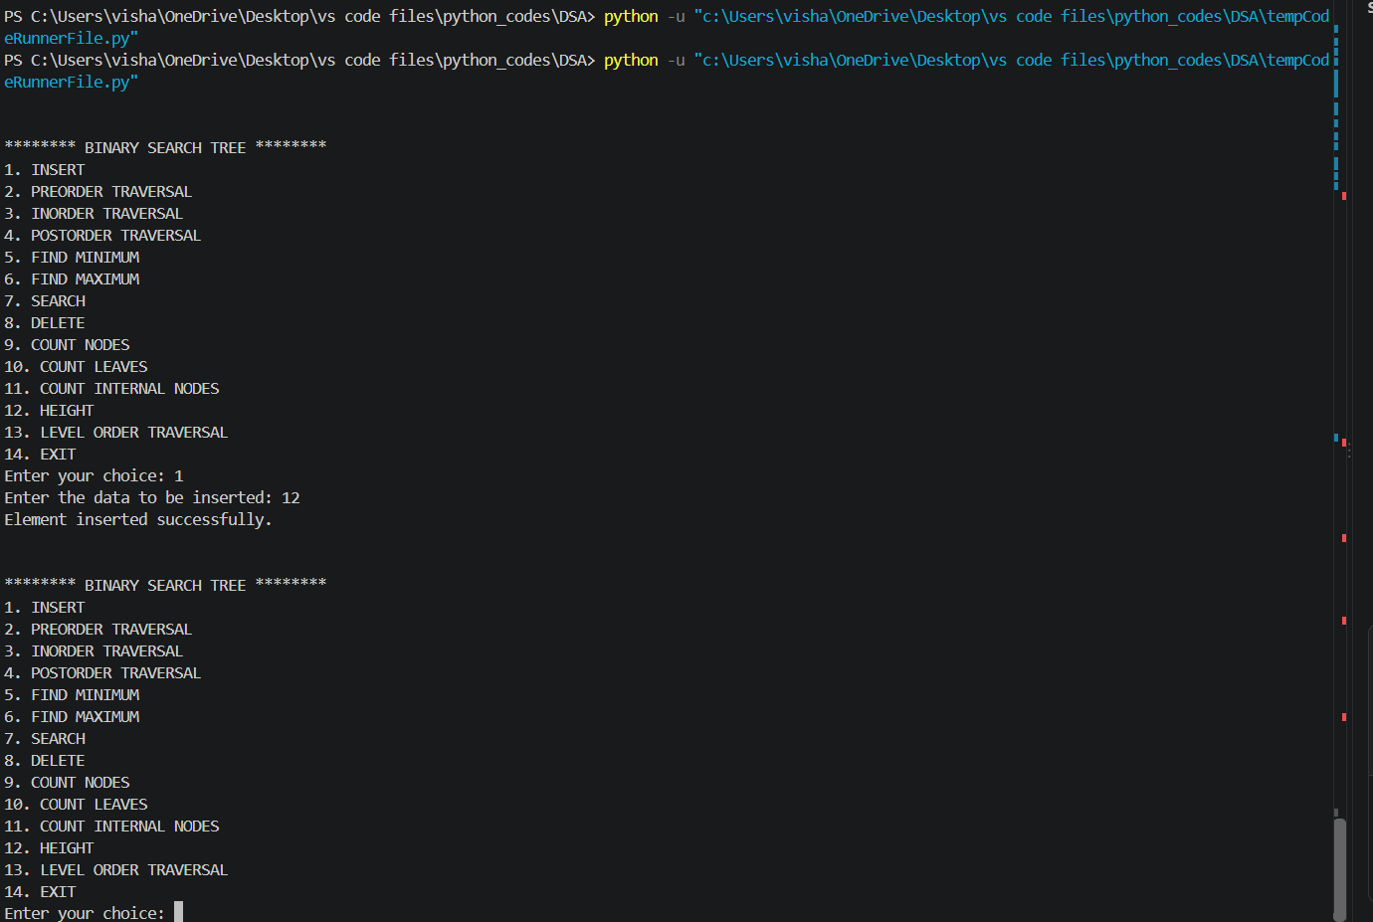

LAB-10:
1) AVL tree operations
class Node:
def __init__(self, x):
self.left = None
self.data = x
self.right = None
self.h = 0

#AVL TREE Program
def height(root):
if root is None:
return -1
else:
return root.h

# LL Rotation
def LL(x):
y = x.left
x.left = y.right
y.right = x
x.h = max(height(x.left), height(x.right)) + 1
y.h = max(height(y.left), height(y.right)) + 1
return y

# RR Rotation
def RR(x):
y = x.right
x.right = y.left
y.left = x
x.h = max(height(x.left), height(x.right)) + 1
y.h = max(height(y.left), height(y.right)) + 1
return y

# LR Rotation
def LR(k3):
k3.left = RR(k3.left)
return LL(k3)

# RL Rotation
def RL(k3):
k3.right = LL(k3.right)
return RR(k3)

# Inorder Traversal
def inorder(root):
if root is not None:
inorder(root.left)
print(root.data, end=" ")
inorder(root.right)

# Preorder Traversal
def preorder(root):
if root is not None:
print(root.data, end=" ")
preorder(root.left)
preorder(root.right)

# Postorder Traversal
def postorder(root):
if root is not None:
postorder(root.left)
postorder(root.right)
print(root.data, end=" ")

# Insert a node into AVL Tree
def insert(root, x):
if root is None:
return Node(x)

if x < root.data:
root.left = insert(root.left, x)
if height(root.left) - height(root.right) == 2:
if x < root.left.data:
root = LL(root)
else:
root = LR(root)

elif x > root.data:
root.right = insert(root.right, x)
if height(root.right) - height(root.left) == 2:
if x > root.right.data:
root = RR(root)
else:
root = RL(root)
else:
print("Duplicates not allowed")
root.h = max(height(root.left),height(root.right)) + 1
return root

# Delete a node from AVL Tree
def delete(root, x):
# Element not found
if root is None:
return None

# Search in left subtree
if x < root.data:
root.left = delete(root.left, x)
if height(root.left) - height(root.right) == 2:
if x < root.left.data:
root = LL(root)
else:
root = LR(root)

# Search in right subtree
elif x > root.data:
root.right = delete(root.right, x)
if height(root.right) - height(root.left) == 2:
if x > root.right.data:
root = RR(root)
else:
root = RL(root)

# When target found
else:
if root.left is None and root.right is None:
root = None
elif root.right is None:
root = root.left
elif root.left is None:
root = root.right
else:
successor = root.right # Find inorder successor
while successor.left is not None:
successor = successor.left
root.data = successor.data #Copy successor data
root.right = delete(root.right, successor.data) # Delete the inorder successor

root.h = max(height(root.left), height(root.right)) + 1
return root

# -------------------------------
# Main Program
# -------------------------------

root = None

while True:

print("\n***** AVL TREE MENU *****")
print("1. INSERT")
print("2. PREORDER TRAVERSAL")
print("3. INORDER TRAVERSAL")
print("4. POSTORDER TRAVERSAL")
print("5. DELETE")
print("6. EXIT")

choice = int(input("Enter your choice: "))
if choice == 1:
data = int(input("Enter the data to be inserted: "))
root = insert(root, data)
elif choice == 2:
print("Preorder Traversal:")
preorder(root)
print()
elif choice == 3:
print("Inorder Traversal:")
inorder(root)
print()
elif choice == 4:
print("Postorder Traversal:")
postorder(root)
print()
elif choice == 5:
data = int(input("Enter the data to be deleted: "))
root = delete(root, data)
elif choice == 6:
print("Program terminated.")
break
else:
print("Invalid choice!")
output :
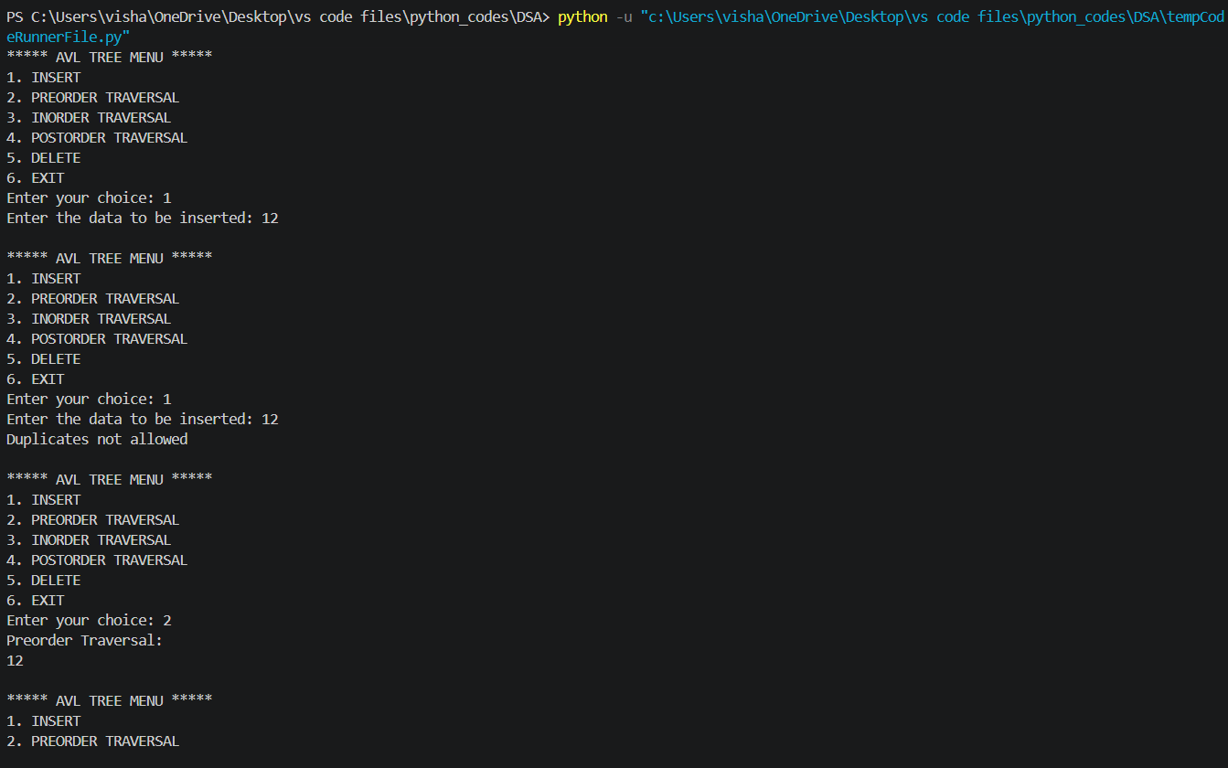

LAB-10:
1)AIM: Heap tree
Program :

def insert(heap, value):
heap.append(value)
i = len(heap) - 1
while i > 0:
parent = (i - 1) // 2
if heap[i] > heap[parent]:
heap[i], heap[parent] = heap[parent], heap[i]
i = parent
else:
break

def delete(heap):
if len(heap) == 0:
print("Heap is empty")
return
print("Deleted element:", heap[0])
heap[0] = heap[-1]
heap.pop()

n = len(heap)
i = 0
# Move the root downward
while True:
largest = i
left = 2 * i + 1
right = 2 * i + 2
if left < n and heap[left] > heap[largest]:
largest = left
if right < n and heap[right] > heap[largest]:
largest = right
if largest != i:
heap[i], heap[largest] = heap[largest], heap[i]
i = largest
else:
break

def display(heap):
if len(heap) == 0:
print("Heap is empty")
else:
print("Heap elements:", heap)

#Main Program
heap = []
while True:
print("\n--- MAX HEAP MENU ---")
print("1. Insert")
print("2. Delete")
print("3. Display")
print("4. Exit")
choice = int(input("Enter your choice: "))
if choice == 1:
value = int(input("Enter value to insert: "))
insert(heap, value)
elif choice == 2:
delete(heap)
elif choice == 3:
display(heap)
elif choice == 4:
print("Exiting program")
break
else:
print("Invalid choice")

program :
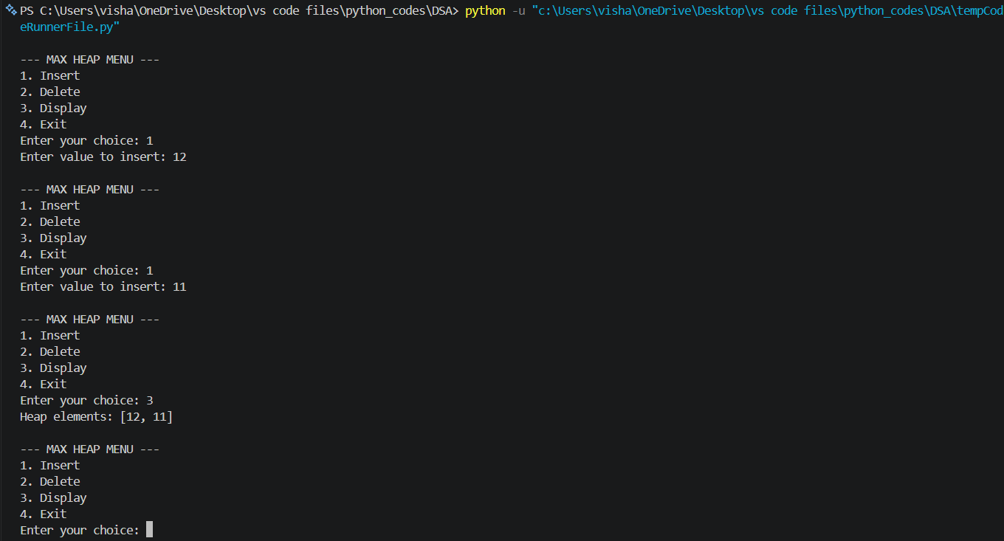

LAB-12:
1) Resolve collisions using separate chaining.
Program :
class Node:
def __init__(self, data):
self.data = data
self.next = None

SIZE = 10
ht = [None] * SIZE

def insertValue(value):
index = value % SIZE
newnode = Node(value)
if ht[index] is None:
ht[index] = newnode
else:
temp = ht[index]
while temp.next is not None:
temp = temp.next
temp.next = newnode

def displayValue():
for i in range(SIZE):
print(i, end=": ")
temp = ht[i]
if temp is None:
print("None")
else:
while temp is not None:
print(temp.data, end=" -> ")
temp = temp.next
print("None")

repeat = True
while repeat:
print("\n1. Insert")
print("2. Display")
print("3. Exit")
ch = int(input("Enter your choice: "))
if ch == 1:
value = int(input("Enter value: "))
insertValue(value)
elif ch == 2:
print("\nHash table values:")
displayValue()
elif ch == 3:
repeat = False
else:
print("Invalid choice")
output :
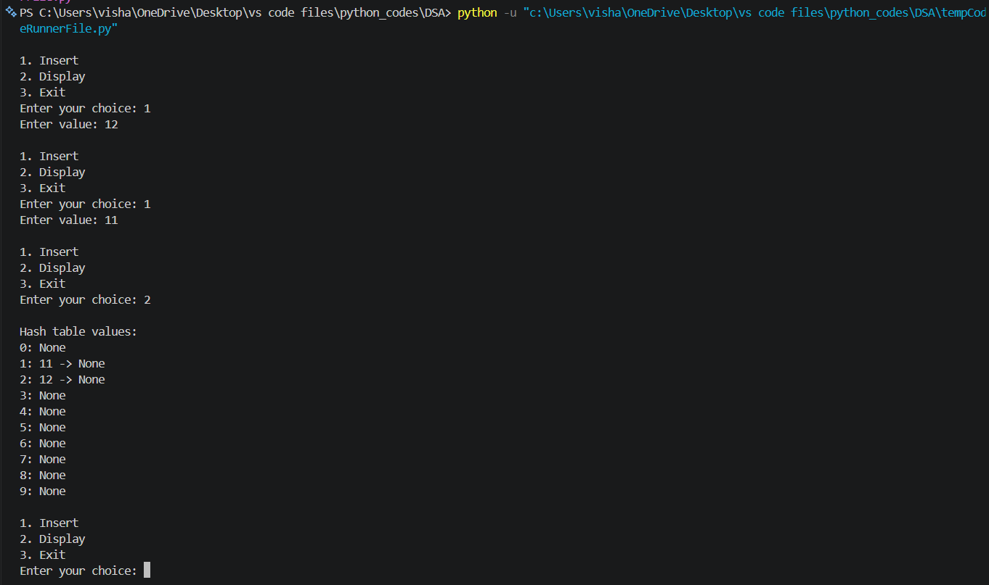
2) Resolve collisions using linear probing.
Program :
SIZE = 10
a = [-1] * SIZE
def insertValue(x):
for i in range(SIZE):
index = ((x % SIZE) + i) % SIZE
if a[index] == -1:
a[index] = x
print("Element inserted")
return
print("Hash table is full")

def deleteValue(x):
for i in range(SIZE):
index = ((x % SIZE) + i) % SIZE
if a[index] == x:
a[index] = -1
print("Element deleted")
return
print("Element not found")

def search(x):
for i in range(SIZE):
index = ((x % SIZE) + i) % SIZE
if a[index] == x:
print("Element found at index", index)
return
if a[index] == -1:
break
print("Element not found")

def displayValue():
print("Index\tValue")
for i in range(SIZE):
print(i, "\t", a[i])

# Menu-driven program
repeat = True
while repeat:
print("\n1. Insert")
print("2. Display")
print("3. Delete")
print("4. Search")
print("5. Exit")
ch = int(input("Enter your choice: "))
if ch == 1:
value = int(input("Enter value: "))
insertValue(value)
elif ch == 2:
print("Values are:")
displayValue()
elif ch == 3:
value = int(input("Enter value to delete: "))
deleteValue(value)
elif ch == 4:
value = int(input("Enter value to search: "))
search(value)
elif ch == 5:
repeat = False
else:
print("Invalid choice")

output:
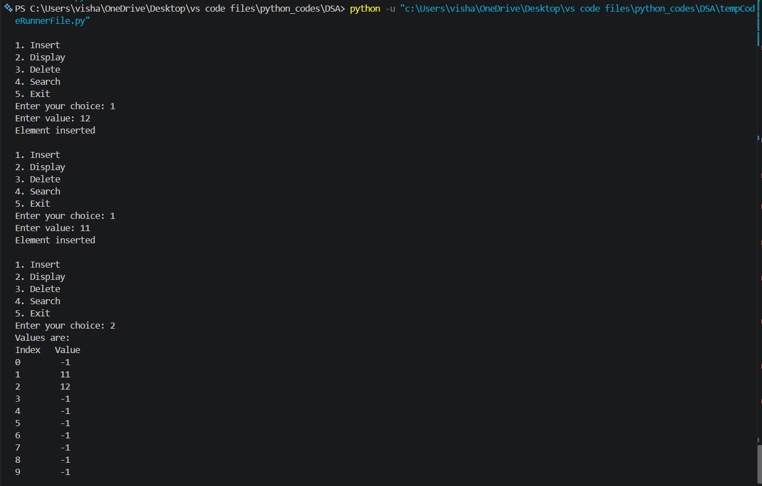
3) Resolve collisions using quadratic probing.
Program :

SIZE = 10
a = [-1] * SIZE

def insertValue(value):
for i in range(SIZE):
index = ((value % SIZE) + i * i) % SIZE
if a[index] == -1:
a[index] = value
print("Element inserted at index", index)
return
print("No empty slot found in the probe sequence")

def displayValue():
print("Values are:")
for i in range(SIZE):
print(a[i])

# Menu-driven program
repeat = True
while repeat:
print("\n1. Insert")
print("2. Display")
print("3. Exit")
ch = int(input("Enter your choice: "))
if ch == 1:
value = int(input("Enter value: "))
insertValue(value)
elif ch == 2:
displayValue()
elif ch == 3:
repeat = False
else:
print("Invalid choice")

output :


